Gluteal Tendinopathy Diagnosis | GTPS
RHH Medical Ltd summary of assessment, technique and post injection advice
December 2019

Assessment
Single leg stance test and palpate.
https://www.youtube.com/watch?v=3vdJhti9tZE&list=PLm1lB2fl1vQ6GHZ5Y7DaS-uWho0M4nkqc

Injection
To tender point and 3-5cm droplets around
10mls injection
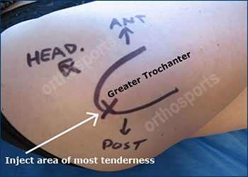

Post injection
After 5 minutes - Observe for any swelling or significant bleed. Any benefit?
Avoid loaded rotation/twisting and lifting for 48hrs
Advise exercises when immediate pain settled as per leaflet https://www.youtube.com/watch?v=477OFkR0syE (type physiotutors GTPS Exercise Protocol)

