Shoulder Subacromial
RHH Medical Ltd summary of assessment, technique and post injection advice
December 2019

Assessment
Local tenderness and scarf positive. No trauma.

Injection
1-2 mls injection
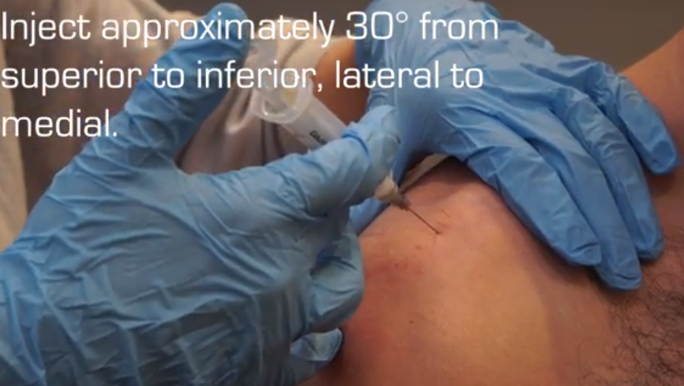
https://www.youtube.com/watch?v=dBZ0srzj4a8 for technique (Medical Skills Courses)

Post injection
After 5 minutes - Observe for any swelling or significant bleed. Any benefit?
Avoid loaded rotation/twisting and lifting for 48hrs
Advise exercises when immediate pain settled as per leaflet
Type in shoulder exercises Versus Arthritis for good Youtube video https://www.youtube.com/channel/UCvBfwJfZIQ6jWKpKYDy7DNw

