Knee injections – only for osteoarthritis
RHH Medical Ltd summary of assessment, technique and post injection advice
December 2019

Assessment
Osteoarthritis signs and symptoms. X ray findings and PF crepitus or medical JL tendernes

Injection
5 mls injection
Anterior approach
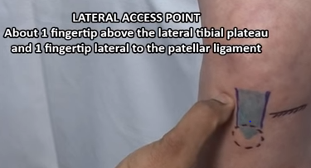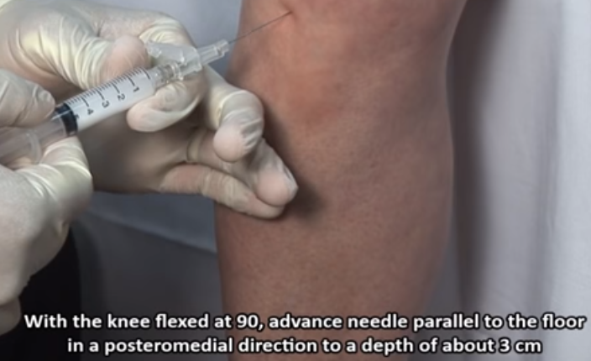
https://www.youtube.com/watch?v=nHGsN1ZeWrI for anterior technique (Rheum tutors)
Lateral approach
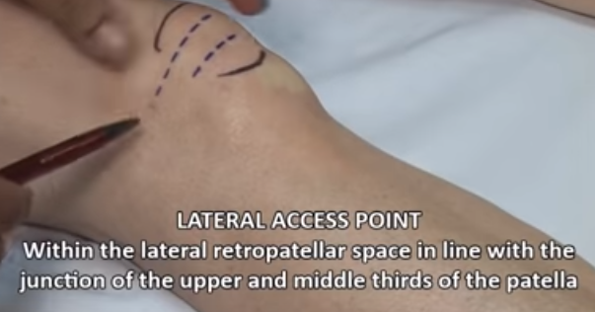
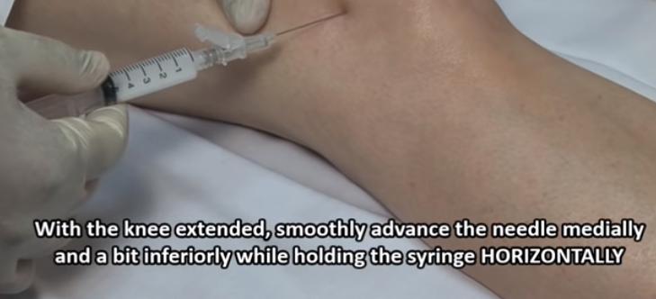
f https://www.youtube.com/watch?v=nuSdJP7LFhU or lateral technique (Rheum tutors)

Post injection
After 5 minutes - Observe for any swelling or significant bleed. Any benefit?
Avoid loaded rotation/twisting and lifting for 48hrs
Advise exercises when immediate pain settled as per leaflet
Type in 10 Minutes to Stronger Knees for good Youtube video https://www.youtube.com/watch?v=UEx09O6FFro

